## Week 1 – Introduction

1. What is the US healthcare cost in 2019?
   1. $3.6 trillion
2. What is the biggest portion of healthcare waste in the US?
   1. Unnecessary care
3. How many people died each year because of preventable errors in US healthcare?
   1. 200K to 400K
4. Find the example data science applications for lower healthcare cost
   1. Predictive models for healthcare utilisation
   2. Early detection for heart failure
5. Which type of healthcare data are considered large in terms of data volume?
   1. Genomic data
   2. Medical imaging data
6. Which type of healthcare data are considered fastest in velocity?
   1. Real-time monitoring data from intensive care units
7. What are diagnosis applications?
   1. Patient triaging
   2. Heart failure detection
   3. Medical imaging analysis
8. What are outcome prediction applications?
   1. Hospital readmission prediction
   2. Length of stay prediction
   3. Mortality prediction
9. What are drug discovery and development applications?
   1. Molecule generation
   2. Clinical trial recruitment
   3. Molecule property prediction
10. Which one is a public health application?
    1. Predicting COVID19 cases at different locations in the US

## Week 2 – Health Data

1. Which of the following is true about electronic health records (EHR)?
   1. Outpatient EHR data are viewed as point events.
   2. Inpatient EHR data are viewed as interval events.
   3. EHR data contain longitudinal patient records.

EHR data is often siloed and incomplete. Data from a single patient can be scattered across multiple hospitals’ EHR’s.

1. Which of the following is true about clinical notes?
   1. They can provide a detailed description of patient status.
   2. Most EHR systems provide clinical notes functionality.
   3. Clinical notes can contain sensitive protected health information.

The unstructured format makes it more difficult for algorithms to process clinical notes.

1. Which of the following are the limitations of claims data?
   1. Coding errors can commonly occur in the claims data.
   2. Since claims data are for billing purposes, they do not accurately reflect patient status.
2. Which of the following are true?
   1. EHR are richer than claims.
   2. EHR captures the medication prescription information but does not capture whether the prescription are filled.
   3. Continuous signals provide objective assessments of patients.
3. What are examples of imaging data?
   1. X-rays
   2. Computed tomography
   3. Magnetic resonance imaging
4. What are the limitations of imaging data?
   1. Ground truth labels are lacking in those images.
   2. The high-resolution imaging data are challenging to process.
5. What is true about medical literature data?
   1. They are difficult to parse because of the natural language format.
6. Which of the following is a medical ontology for medications?
   1. RxNorm
7. What are clinical trial data?
   1. Trial protocols
   2. Trial eligibility criteria
   3. Data in clinical trial manage systems
8. What’s true about drug data?
   1. Drugs are often represented in molecule structures.
   2. Drug data are standard.
   3. ChEMBL is a large bioactivity database.

3D molecule structures are important by still uncommon.

## Week 3 – Machine Learning Basics

1. What are the steps in a clinical predictive modelling pipeline?
   1. Define prediction target
   2. Data gathering
   3. Cohort construction
   4. Feature construction
   5. Prediction model
   6. Model Evaluation
2. How do you know if a prediction target is possible?
   1. Human performance as the target goal
   2. Define what the prediction target needs to achieve based on business needs.
   3. Prior experience from previous projects
   4. Results from related publications
3. What is true about retrospective studies?
   1. Retrospective studies need to handle a lot of noise in the data.
   2. The dataset used in a retrospective study is often already collected for different purposes than the study itself.
4. Which of the following are true about cohort construction?
   1. A cohort study is about identifying a group of patients who are exposed to the risk of the prediction target.
   2. A case-control study will first identify the case patients then match them to the control patients.
   3. Matching criteria in case-control studies have a small impact on the resulting cohort.
   4. Case control studies are easier to conduct than cohort studies.
5. Which of the following are true about feature construction in building a predictive model?
   1. One should always try to create as many features as possible.
   2. The longer the prediction window, the easier the prediction task is.
   3. The shorter the observation window, the harder the prediction task is.
   4. Longer prediction can limit the amount of data that can be used for building the predictive model.
6. Which of the following are standard/good practice for building clinical predictive models?
   1. Cross-validation are most commonly used for evaluating deep learning models.
   2. For training deep learning models, it is important to keep validation and test sets large.
   3. Validation and Test sets can be small but should contain realistic samples with high-quality labels.
   4. Training data can be large and flexible, even with potentially noisy data.
7. What is the time complexity of K-means algorithm given n is # of points, k is # of clusters, d is the dimensionality of each point, and i is the number of clustering iterations?
   1. n*d*d*i*k
   2. n*d*i*k
   3. n*d*i*k*k
   4. n*sqrt(d)*i*k
8. Fill in the Blanks in this order: Total Population, Condition Positive, True Positive, Prediction Outcome Negative, True Negative.

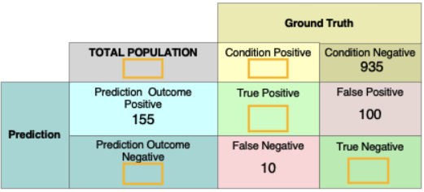

1. What is the definition of recall or sensitivity?
   1. True positive / (true positive + false negative)
2. Fill in the blanks in this order: True Positive Rate, False Positive Rate, False Negative Rate, True Negative Rate.

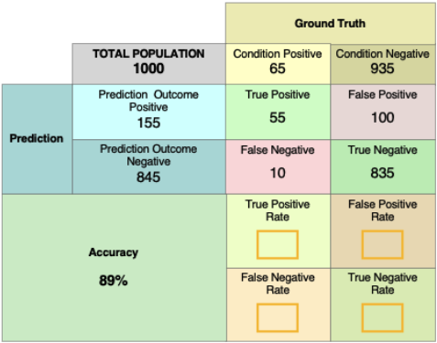

* 1. J

## Week 4 – Deep Neural Networks

1. Skip to Main Content
3. Search in course
4. • •
5. • Week 4
6. • Deep Neural Networks
7. •
8. •
9. Practice Quiz: Deep Neural Networks
10. . Duration: 30 minutes30 min
11. • • Deep Neural Networks
12. Submit your assignment
13. Receive grade
14. To Pass 80% or higher
15. Your grade
16. -Not available
17. Deep Neural Networks
18. Practice Quiz. • 30 min. • 10 total points available.10 total points
19. • 1.
20. Question 1
21. Which of the following is NOT true about activation functions?
22. 1 point
23. Activation functions describe non-linear transformation
24. Activation functions are specified by the user when setting up the neural network architectures
25. Activation functions are learned directly from the data by neural network models.
26. ReLU is able to cope with vanishing gradient problems better than Sigmoid and Tanh.
27. 2.
28. Question 2
29. What is NOT true about gradient descent?
30. 1 point
31. Log-likelihood and likelihood function has the same optimal but log-likelihood is often easier to manipulate.
32. Gradient descent is an optimization method for optimizing model parameters
33. Gradient descent is a specific design method for neural network optimization.
34. Stochastic gradient descent is a variant of the gradient descent method that is popular for neural networks training.
35. 3.
36. Question 3
37. In forward computation, how is weight W12(1)W12(1) used?
38. 1 point
39. Connect neuron x1 from the input layer to output neuron h2 in the second layer
40. Connect neuron x2 from the input layer to output neuron h1 in the second layer
41. Connect neuron h1 from the second layer to output neuron h2 in the third layer
42. Connect neuron h2 from the second layer to output neuron h1 in the second layer
43. 4.
44. Question 4
45. In the general form of forward computation, the weight matrix W(l)W(l) and bias vector b(l)b(l)are used to connect?
46. 1 point
47. Pre-activation z(l)z(l) and activation a(l)a(l)
48. Pre-activation z(l+1)z(l+1) and activation a(l)a(l)
49. Pre-activation z(l)z(l) and activation a(l+1)a(l+1)
50. Pre-activation z(l+1)z(l+1) and activation a(l+1)a(l+1)
51. 5.
52. Question 5
53. What is true about back propagation?
54. 1 point
55. Back propagation is an efficient way to compute derivatives on parameters on a neural network.
56. Back propagation does not require any form of forward pass of the neural network.
57. Most deep learning packages require users to specify the derivatives of each layer in order to perform back propagation
58. Back propagation is a new algorithm invented specifically for training deep learning models.
59. 6.
60. Question 6
61. Which is NOT true about Multilayer Neural Networks?
62. 1 point
63. There is no bias term in the input layer.
64. An activation function aa is applied before the linear combination zz.
65. The linear combination of layer 2 is computed as
66. zi(2)=∑j(wij(1)xj+bj)zi(2)=∑j(wij(1)xj+bj)
67. Multilayer neural networks are computed more efficiently on GPU.
68. 7.
69. Question 7
70. Which is NOT true in the readmission study using DNN?
71. 1 point
72. Multiple layers of DNN can help construct better features before the final classification layer.
73. Separate DNNs are trained for the 5 different disease cohorts.
74. DNN models achieved better accuracy than logistic regression models in this study.
75. DNN can provide a clear interpretation of its prediction.
76. 8.
77. Question 8
78. Which of the following forward computation equation is NOT correct?
79. 1 point
80. z1(2)=∑j(w1j(1)xj+bj(1))z1(2)=∑j(w1j(1)xj+bj(1))
81. a1(2)=g(2)(z1(2))a1(2)=g(2)(z1(2))
82. a2(2)=g(1)(z2(1))a2(2)=g(1)(z2(1))
83. z2(3)=∑j(w2j(2)aj(2)+bj(2))z2(3)=∑j(w2j(2)aj(2)+bj(2))
84. 9.
85. Question 9
86. Why do you think DNN is a good model for QSAR applications?
87. 1 point
88. Your answer cannot be more than 10000 characters.
89. 10.
90. Question 10
91. Which one is NOT true about hospital readmission?
92. 1 point
93. Readmission often indicates low-quality in the original admission.
94. Different neural models can be trained for readmission for different diseases.
95. It is essential to identify a small number of relevant features for predicting readmission using deep neural networks.
96. Readmission can happen due to non-clinical reasons such as social determinants of health.